**Software Requirements**

**Specification**

**for**

# SKANDA

# by Sarasi Samarasundara

**Version 1.0**

**Prepared by**

S. K. Helani Sihara Jayawardena, M. Sonali Silva

**SKANDA by Sarasi Samarasundara**

**02/25/2022**

## Revision History

|  |  |  |  |
| --- | --- | --- | --- |
| **Name** | **Date** | **Reason for Changes** | **Version** |
| **SRS** | 02/24/2022 | First issue | 1.0 |

**Approvals**

This document requires the following approvals.

Signed approval forms are filed in the Management section of the project files.

|  |  |  |  |  |
| --- | --- | --- | --- | --- |
| **Name** | **Signature** | **Title** | **Date of Issue** | **Version** |
| Dr. Yasas Jayaweera |  | Project Board | 02/24/2022 | 1.0 |
| Adithya Narasinghe |  | Project Manager | 02/24/2022 | 1.0 |
| Mrs. Sarasi Samarasundara |  | Client | 02/24/2022 | 1.0 |

## Table of Contents

1. Introduction ............................................................................................................................... 6

 Purpose ................................................................................................................................ 6

 Document Conventions ....................................................................................................... 6

 Intended Audience and Reading Suggestions ..................................................................... 7

 Product Scope ...................................................................................................................... 7

1. Overall Description ................................................................................................................... 8

 Product Perspective ............................................................................................................. 8

 Product Functions ................................................................................................................ 9

 User Classes and Characteristics ......................................................................................... 9

 Operating Environment ....................................................................................................... 10

 Design and Implementation Constraints.............................................................................. 10

 User Documentation ............................................................................................................ 10

1. External Interface Requirements ............................................................................................. 11

 Common Interfaces for admin and users ............................................................................. 11

3.1.1 Login Page.................................................................................................................... 11

3.1.2 Registration Page.......................................................................................................... 12

 Admin interfaces................................................................................................................ 13

3.2.1 Admin Dashboard ...................................................................................................... 13

3.2.2 Add new products....................................................................................................... 14

3.2.3 Product Inventory ....................................................................................................... 15

3.2.4 View and Manage Orders ........................................................................................... 16

 User interfaces ................................................................................................................... 17

3.3.1 Checkout Page ............................................................................................................ 17

3.3.2 Home Page ................................................................................................................. 18

3.3.3 Single Product View................................................................................................... 19

 Software Interfaces ............................................................................................................ 20

3.4.1 User Interface prototyping.......................................................................................... 20

3.4.2 Web site frontend ....................................................................................................... 20

3.4.3 Web site Backend ....................................................................................................... 20

3.4.4 Programming Language and Development Framework ............................................. 20

3.4.5 Web API Development IDE ....................................................................................... 20

 Communications Interfaces ............................................................................................... 20

3.5.1 Communication Security ............................................................................................ 21

4 System Features........................................................................................................................ 22

 Use Case Diagram ............................................................................................................. 22

 Use Case Scenarios ............................................................................................................ 23

4.2.1 Login .......................................................................................................................... 23

4.2.2 Manage Products ........................................................................................................ 24

4.2.3 Manage Categories ..................................................................................................... 25

4.2.4 View and Manage Orders ........................................................................................... 26

4.2.5 Cart Management ....................................................................................................... 27

4.2.6 Purchase Products ...................................................................................................... 28

 Class Diagram.................................................................................................................... 29

 Entity Relationship Diagram ............................................................................................. 30

 Activity Diagram ............................................................................................................... 31

1. Other Nonfunctional Requirements ......................................................................................... 32
   1. Performance Requirements ................................................................................................ 32
   2. Safety Requirements .......................................................................................................... 33
   3. Security Requirements ....................................................................................................... 33
   4. Software Quality Attributes ............................................................................................... 34
2. Other Requirements.................................................................................................................. 35
3. Appendix A: Glossary ............................................................................................................. 36

## List of Tables

Table 1: System Functions 9

Table 2: Use case scenario for login 23

Table 3: Use case scenario for manage products 24

Table 4: Use case scenario for manage categories 25

Table 5: Use case scenario for view and manage oders 26

Table 6: Use case scenario for cart management 27

Table 7: Use case scenario for purchase products 28

Table 8: Definitions, Acronyms, and Abbreviations 36

## List of Figures

Figure 1: High-Level Architecture Diagram 8

Figure 2: Login Interface 11

Figure 3: Registration Page 12

Figure 4: Admin Dashboard 13

Figure 5: Add new products-Interface 14

Figure 6: Products Inventory 15

Figure 7: View and Manage Orders 16

Figure 8: Checkout Page 17

Figure 9: Home page 18

Figure 10: Single Product View 19

Figure 11: Use Case Diagram 22

Figure 12: Class Diagram 29

Figure 13: Entity Relationship Diagram 30

Figure 14: Activity Diagram 31

## 1 Introduction

### Purpose

This Software Requirement Specification highlights the main objective of the SKANDA E-commerce website project. SKANDA, owned by Mrs Sarasi Samarasundara, is a well-known clothing brand in Sri Lanka, where the main outlet is in Borella, Sri Lanka. The COVID-19 pandemic has had a significant impact on the business, which caused sales and revenue drop. To scale up while increasing revenue and sustaining with technology advancement, the company has decided to adopt an online experience and convert the business to both online and physical locations. This document will contain the functional and non-functional requirements for the proposed system as specified by the client during the virtual meetings. This document defines the scope of the project and illustrates the criteria that the outcome will include.

### Document Conventions

This SRS Document was prepared using Google Docs. Each main topic commenced on a new page. The line spacing throughout the document is 1.5. The font types used are Times New Roman and Arial. The title levels and their formatting are listed below:

#### Main Titles

* Font: Times New Roman
* Face: Bold
* Size: 18

#### Level Two Titles

* Font: Times New Roman
* Face: Bold
* Size: 14

#### Level Three Titles

* Font: Times New Roman
* Face: Bold
* Size: 12

#### Other Titles

* Font: Times New Roman
* Face: Normal and Underlined
* Size: 12

#### Body Text

* Font: Times New Roman
* Face: Normal
* Size: 12

#### Image & table captions

* Font: Times New Roman
* Face: Normal
* Size: 10

### Intended Audience and Reading Suggestions

This document is being developed to demonstrate to developers, project managers, quality assurance engineers, and documentation authors the program's capabilities and scope by explaining the implementation side of the system. The document includes both graphical and textual inner workings of the proposed system, illustrating how each capability works in detail. All readers can benefit from the introduction, overall description, and various functional and non-functional needs. This document may be read from any subject specified in the text as needed by the reader. External interface requirements and system features give information that is primarily targeted at non-users.

### Product Scope

By eliminating the need to manually handle orders that are placed over the phone or using social media chats, the suggested system would assist users in maintaining their profile, purchases, and transactions. The ultimate result will be an easy-to-use e-commerce system that helps users to easily place their orders remotely. The system and transactions will be more productive, efficient, and time-saving by using new technology (AI-based chatbot).

## 2 Overall Description

### Product Perspective

The project's end deliverable will be an e-commerce system with an AI-based chatbot that is viewable & usable on any modern platform. The product will include an interface and other features as described in the proposed project's product description document.

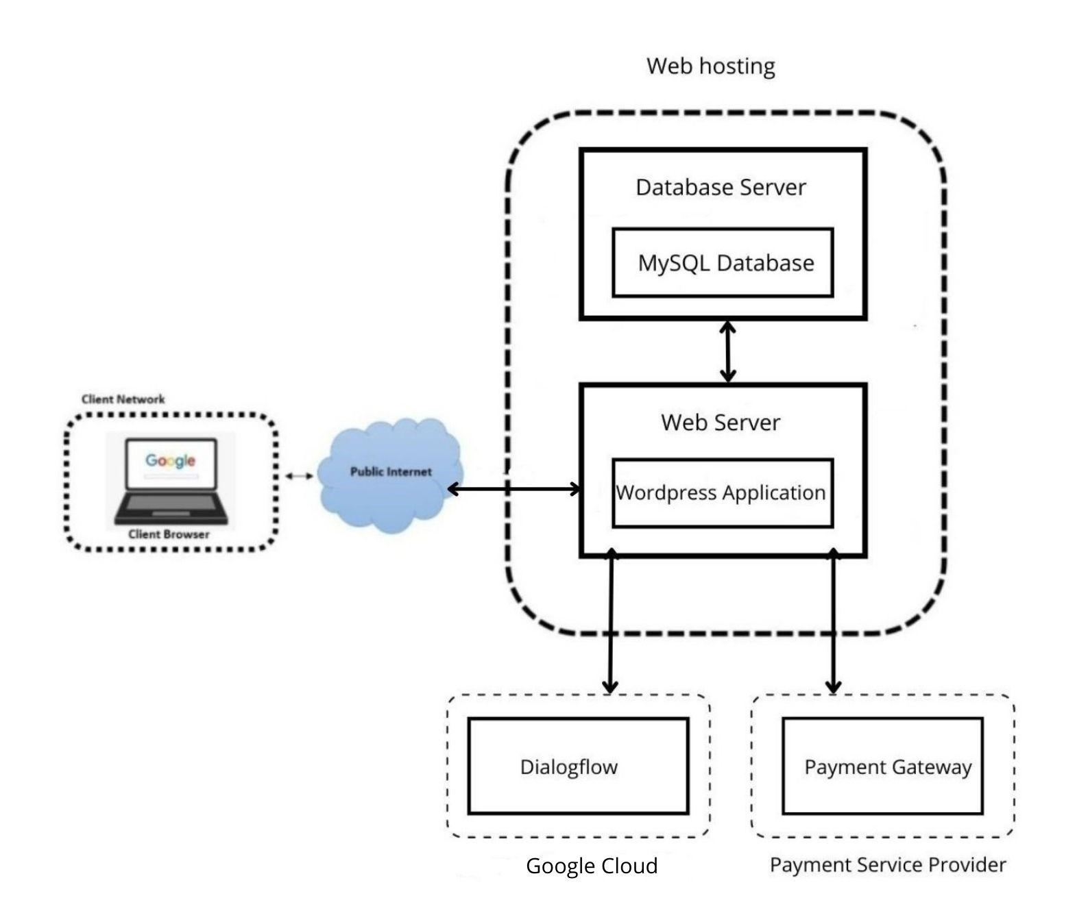

*Figure 1: High-Level Architecture Diagram*

### Product Functions

The tasks outlined here will provide a brief overview of each user's functions. These activities are addressed in further detail in Section 4.0, System Features.

*Table 1: System Functions*

|  |  |
| --- | --- |
| **User** | **Function** |
| **Admin** | * Login to the system * Add products * View products * Delete Products * Update Products * Manage Categories * View & manage orders * Track & update stocks * View and respond to customer feedback. |
| **Users** | * Log-in to the system * Creates a user account * Add products to the cart * View & manage shopping cart * Purchase products * Make online payments * Search products * Spinning wheel * Chatbot |

### User Classes and Characteristics

There will be two types of users engaging with the system.

1. **System Admin** – The administrator has complete control over the system's functionalities and can manage the whole E-Commerce website.
2. **Customers/Users** – Users can see and purchase products, but they have limited access to the website's functionalities. Users can also manage their profiles and seek Chabot's assistance.

### 2.4 Operating Environment

**Server Requirements**

On the server-side, a shared hosting service will be utilized. The hosting service will need to have the following software requirements,

* Apache Web Server
* PHP 7.0
* MySQL

**Client Requirements**

On the users side, any modern device which has an active internet connection, and has any modern web browser installed will be able to use this e-commerce website.

### Design and Implementation Constraints

The following constraints might be considered while considering the design and implementation constraints of Sarasi Samarasundara's project "SKANDA."

* Time constraint – Mid-April, 2022 must complete the project.
* Cost constraint – No additional cost items are included within this project's scope.
* Proposed solution should support a wide range of web browsers and mobile devices.
* Software licensing related processes are not deemed to be part of this project.
* Technology and organizational assessments of the current environment.
* Customer resource management and data mining components.

The project team is currently experiencing no major risks. However, due to the limited period and changing functionality based on the user, the team may experience planned possible risks when carrying out the project.

 **User Documentation**

The user manual will be sent with the system to provide instructions on how to use it effectively, and hands-on training will be provided during the user acceptance testing phase. Additionally, online assistance will be available during working hours.

## 3 External Interface Requirements

The following are the conceptual designs that show product functionality and the user components that should be included in each screen. The final designs will capture the same components and functionality, but they might have a different design, which will be finalized after the selection of a wordpress theme.

### Common Interfaces for admin and users

#### 3.1.1 Login Page

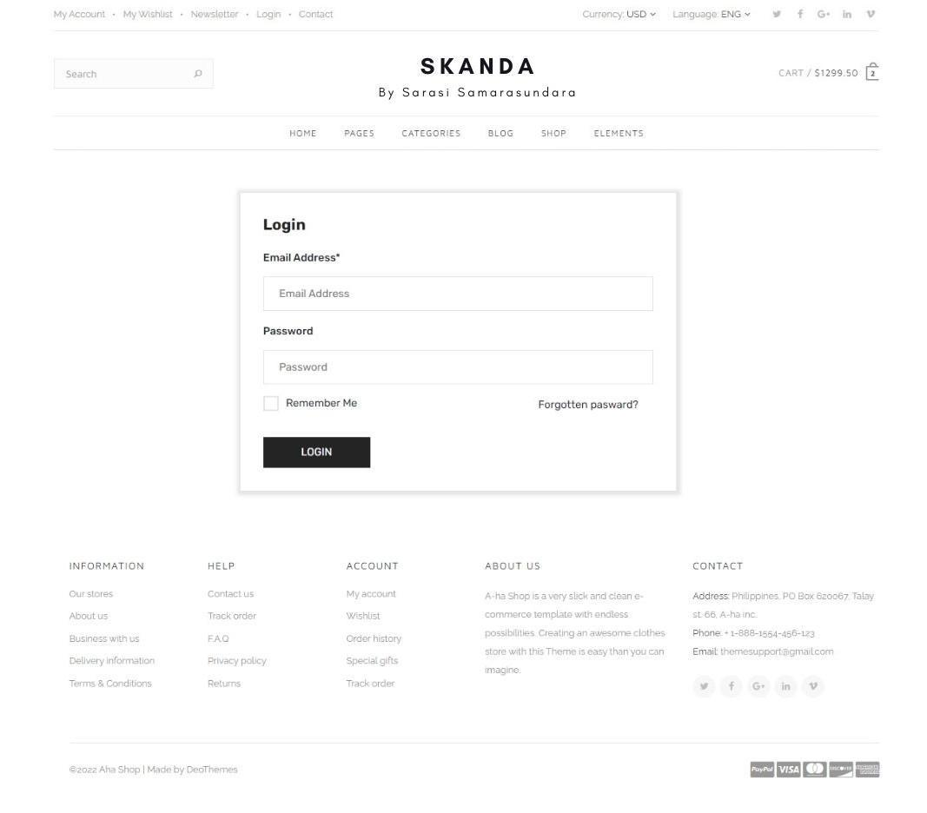

*Figure 2: Login Interface*

To access the system, all users and administrators must log in using valid credentials. This is done to authenticate the user and maintain the appeal store's information integrity to avoid unwanted threats and other concerns. This is a critical phase that is also a high-security necessity.

#### 3.1.2 Registration Page

This part of the system registers the user details to maintain accurate information of every user in the database. A new user first has to register themselves to log in.

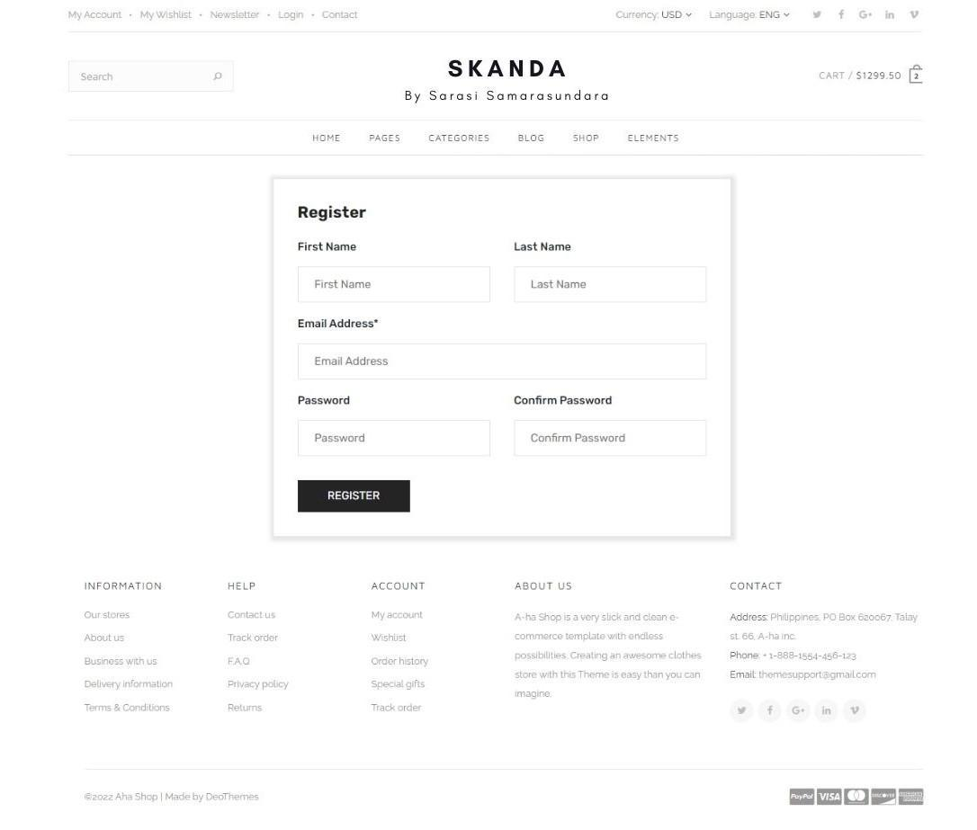

*Figure 3: Registration Page*

 Admin interfaces

#### 3.2.1 Admin Dashboard

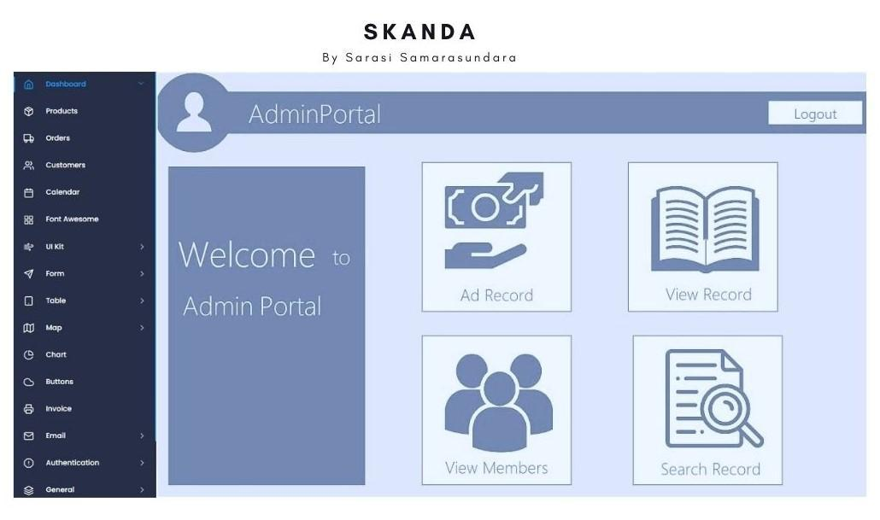

*Figure 4: Admin Dashboard*

The admin may use this interface to add new products, examine orders, check inventories, and view member details. This allows the administrator to keep track of sales and inventory

#### 3.2.2 Add New Product

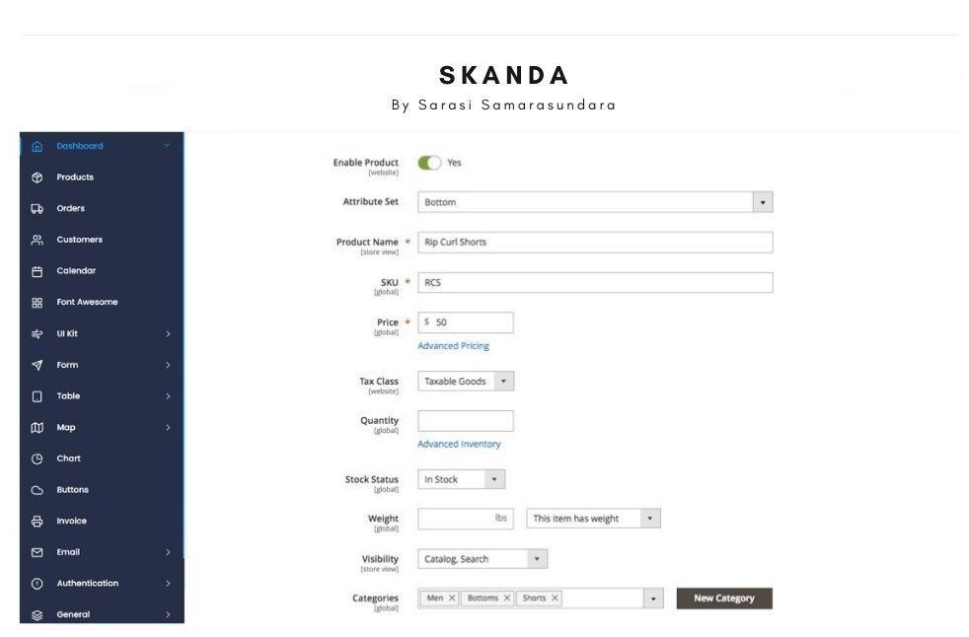

This interface allows the admin to add products to the website where he can view the product price, categories, discounts and etc.

*Figure 5: Add new products-Interface*

This interface allows the administrator to add products to the website and view their prices, categories, and discounts, among other things.

#### 3.2.3 Product Inventory

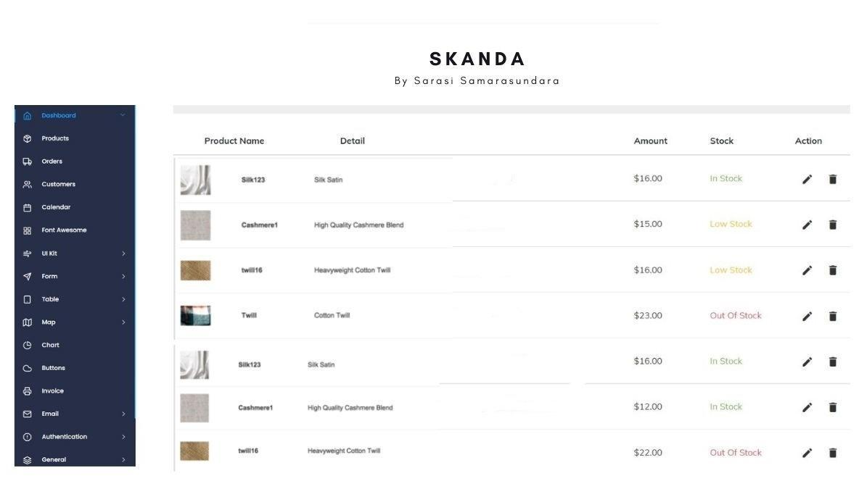

*Figure 6: Products Inventory*

The admin may use this interface to keep track of the items that are posted on the website.

#### 3.2.4 View and Manage Orders

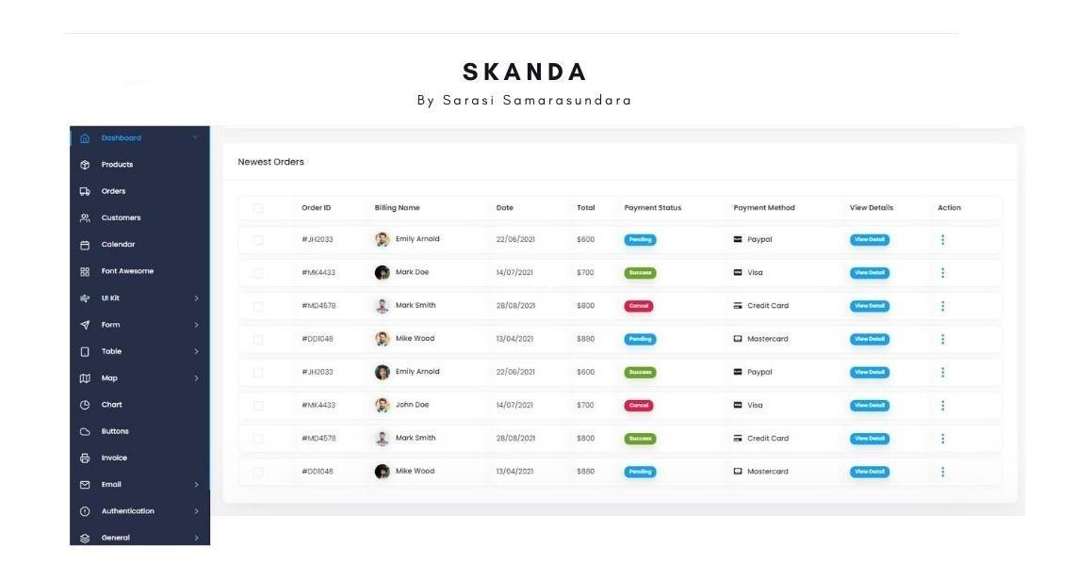

*Figure 7: View and Manage Orders*

This interface allows the administrator to review the orders placed by users. i.e., order information and status (processing, order received, order delayed)

### User interfaces

#### 3.3.1 Checkout Page

This will be the checkout page for consumers who purchase through the apparel store's E-Commerce website. Customers may also examine their shopping basket, which displays information such as amount, item code, size, price, and shipping information, among other things.

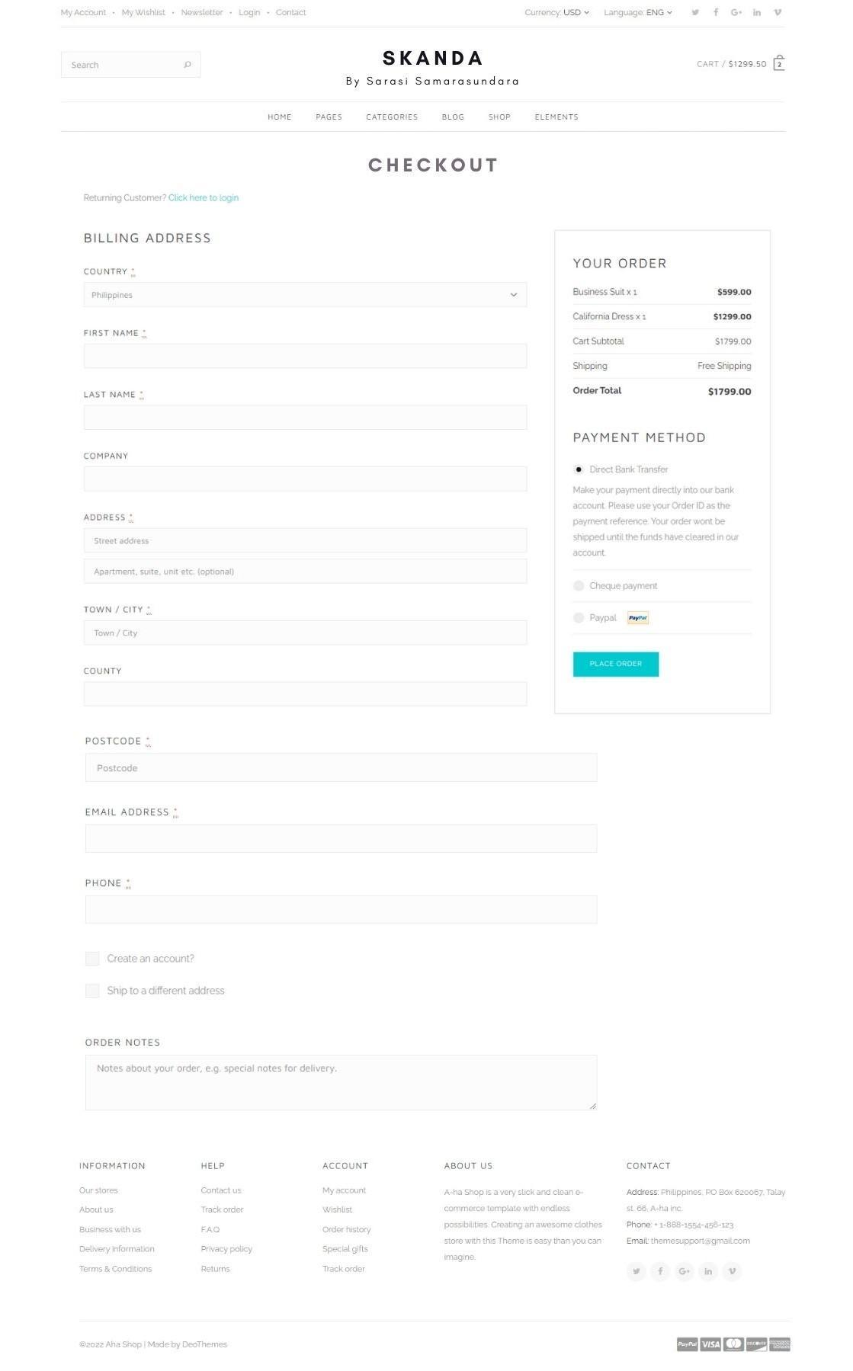

*Figure 8: Checkout Page*

#### 3.3.2 Home Page

*Figure 9: Home page*

#### 3.3.3 Single Product View



*Figure 10: Single Product View*

### Software Interfaces

### 3.4.1 User Interface prototyping

Tool- Figma

Figma was used to design mock interfaces for the website to aid in deciding how to include the functionalities for the website.

**3.4.2 Content Management System**

The system will be built using the WordPress content management platform, which was built using PHP.

**3.4.3 Database**

MySQL database will be used to store the data for wordpress.

#### 3.4.4 E-Commerce Functionalities

WooCommerce, which is the de facto plugin used for creating e-commerce websites with wordpress will be used to create the e-commerce functionalities.

#### 3.4.5 AI Chatbot

Google DialogFlow will be used to train and implement the AI based chatbot.

### Communications Interfaces

This chapter explains the proposed communication mechanisms used by Skanda E-Commerce Website and the necessary steps to be taken to ensure the security of information.

**3.5.1 Communication functions**

The communication architecture must follow the client-server model. Communication between the client and server should utilize a REST-compliant web service provided by wordpress. The interactions with the payment service provider will be handled using the SDK provided by the payment service provider. Communication between the Chatbot frontend and backend will be handled using the REST-full APIs provided by DialogFlow.

#### 3.5.2 Communication Security

In order to secure sensitive information such as login credentials, all the communications will happen over the HTTPS protocol. Other than that, the user will directly interact with the payment service provider and the payment service provider will provide a client id for each customer and communicate the status of the payment, which removes the burden of securely storing the payment details of the customers in the system database.

## 4 System Features

Use case diagrams including use case scenarios, class diagrams, sequence diagrams, Activity diagrams, and ER diagrams are used to show the system's primary functional needs

### Use Case Diagram

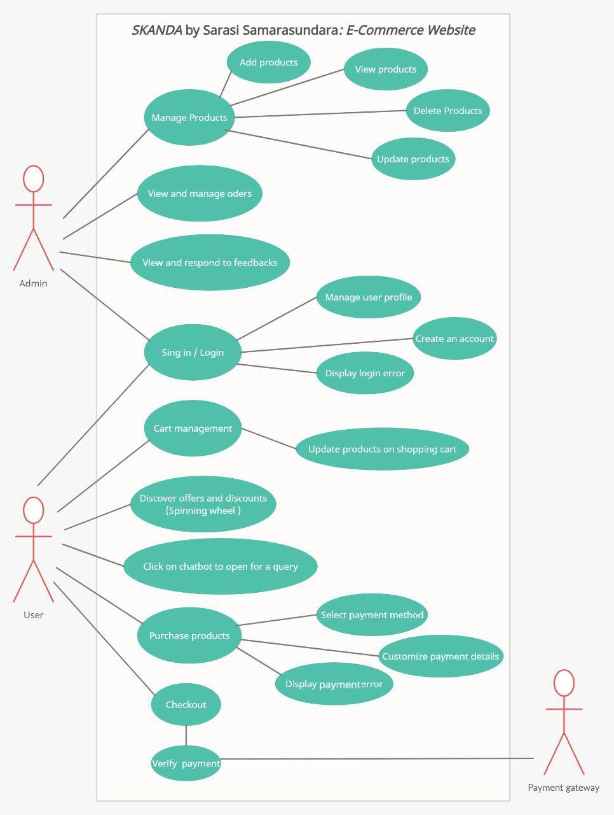

*Figure 11: Use Case Diagram*

### Use Case Scenarios

#### 4.2.1 Login

*Table 2: Use case scenario for login*

|  |  |  |
| --- | --- | --- |
| Use case ID | 01 | |
| Use case Name: | Login | |
| Actors | Administrator, Consumer | |
| Pre-Condition | The user is not logged in to the system. | |
| Post Condition | The user logged in to the system | |
|  | Action | System Response |
| Success Path | 1. The use case starts when the user clicks on the login icon. | 1. Display the login UI |
|  | 1. The user enters their username and password |  |
|  | 1. The user clicks the ‘login’ icon to access the website. | 1. Authenticate the user's login credentials. |
|  |  | 1. Open the main GUI for the user. |
| Alternative Path | 1. If the provided username and password are not matched with the stored data, the system displays an error message. 2. If the user clicks on the signup icon, the user will be redirected to the signup page. |  |
| Special  Requirements | None |  |

#### 4.2.2 Manage Products

*Table 3: Use case scenario for manage products*

|  |  |  |
| --- | --- | --- |
| Use case ID | 02 | |
| Use case Name: | Manage Products | |
| Actors | Administration | |
| Pre-Condition | Admin user logged in to the system | |
| Post Condition | The product details get updated in the system. | |
|  | Action | System Response |
| Success Path | 1. Admin click on the Manage Products icon | 2. Display the Manage Products UI |
|  | 3. Admin user chooses CRUD operations (such as view, edit, update, add or delete products.) |  |
|  |  | 4. System request for confirmation |
|  | 5 Admin user click to confirm. | 6. Product is updated |
| Exception Path | 4:1. Required fields are not filled or completed | 4:1:1. System display error message |
|  | 4:1:2. Admin user fills the required fields |  |
|  | 4:1:3. Admin user clicks Update | 4:1:4. The system continues the process from step 5 |
| Special  Requirements | none |  |

#### 4.2.3 Manage Categories

*Table 4: Use case scenario for manage categories*

|  |  |  |
| --- | --- | --- |
| Use case ID | 03 |  |
| Use case Name: | Manage Categories |  |
| Actors | Administration |  |
| Pre-Condition | Admin user logged in to the system |  |
| Post Condition | The category details get updated in the system. | |
|  | Action | System Response |
| Success Path | 1. Admin user clicks on Edit Category tab. | 2. Display the Edit Category UI |
|  | 3. Admin user chooses CRUD operations (such as view, edit, update, add or delete cateogories.) |  |
|  |  | 4. System request confirmation. |
|  | 5. Admin user clicks to confirm. |  |
|  |  | 6. Categories are updated |
| Exception Path | 4:1. Required fields are not filled or completed | 4:1:1. System display error message |
|  | 4:1:2. Admin user fills the required fields |  |
|  | 4:1:3. Admin user clicks Update | 4:1:4. The system continues process from step 5 |
| Special  Requirements | None |  |

#### 4.2.4 View and Manage Orders

*Table 5: Use case scenario for view and manage oders*

|  |  |  |
| --- | --- | --- |
| Use case ID | 04 | |
| Use case Name: | View and Manage Orders | |
| Actors | Administration | |
| Pre-Condition | Admin user logged in to the system | |
| Post Condition | Admin user views the order details | |
|  | Action | System Response |
| Success Path | 1. Admin user click transaction tab |  |
|  |  | 2. The system displays the Transaction UI |
|  |  | 3. The system displays the details of each transaction in table |
|  | 4. Admin user clicks orders tab |  |
|  |  | 5. The system displays the orders UI |
|  |  | 6. The system displays each order detail in a table |
| Exception Path | 4:1. If transactions and orders are null, | 4:1:1. The system displays an empty table |
| Special  Requirements | none |  |

**4.2.5** **Cart Management**

*Table 6: Use case scenario for cart management*

|  |  |  |
| --- | --- | --- |
| Use case ID | 05 |  |
| Use case Name: | Cart Management |  |
| Actors | Consumer |  |
| Pre-Condition | The consumer is on the website | |
| Post Condition | The consumer views their shopping cart | |
|  | Action | System Response |
| Success Path | 1. The consumer clicks the cart tab. | 2. The system displays the cart UI |
|  |  | 3. The system displays the details of each item that has been added to the cart with the price and quantity. |
| Alternative Path | 1:1. If there are no products in the cart, | 1:1:1. The system displays an empty table. |
| Special  Requirements | none |  |

#### 4.2.6 Purchase Products

*Table 7: Use case scenario for purchase products*

|  |  |  |
| --- | --- | --- |
| Use case ID | 06 | |
| Use case Name: | Products purchase | |
| Actors | Consumer | |
| Pre-Condition | The consumer is logged in to the system, have added items to the cart and are in the shopping cart page. | |
| Post Condition | The consumer completes the purchase. | |
|  | Action | System Response |
| Success Path | 1. The consumer clicks the Purchase button. |  |
|  |  | 2. The system redirects to purchase UI |
|  | 3. The consumer fills the required fields with the shipping details and clicks purchase. |  |
|  |  | 4. System request confirmation |
|  | 5. The user clicks on Confirm |  |
|  |  | 6. Redirects to payment gateway |
|  | 7. User completes the payment |  |
|  |  | 8. The user gets redirected to the Order received page. |
| Alternative Path | 1:1.If the selected product is out of stock, | 1:1:1. The system displays out of stock message |
|  | 2:1. If the payment fails | 2:1:1. The system shows order failed page. |
| Special  Requirements | none |  |

### Class Diagram

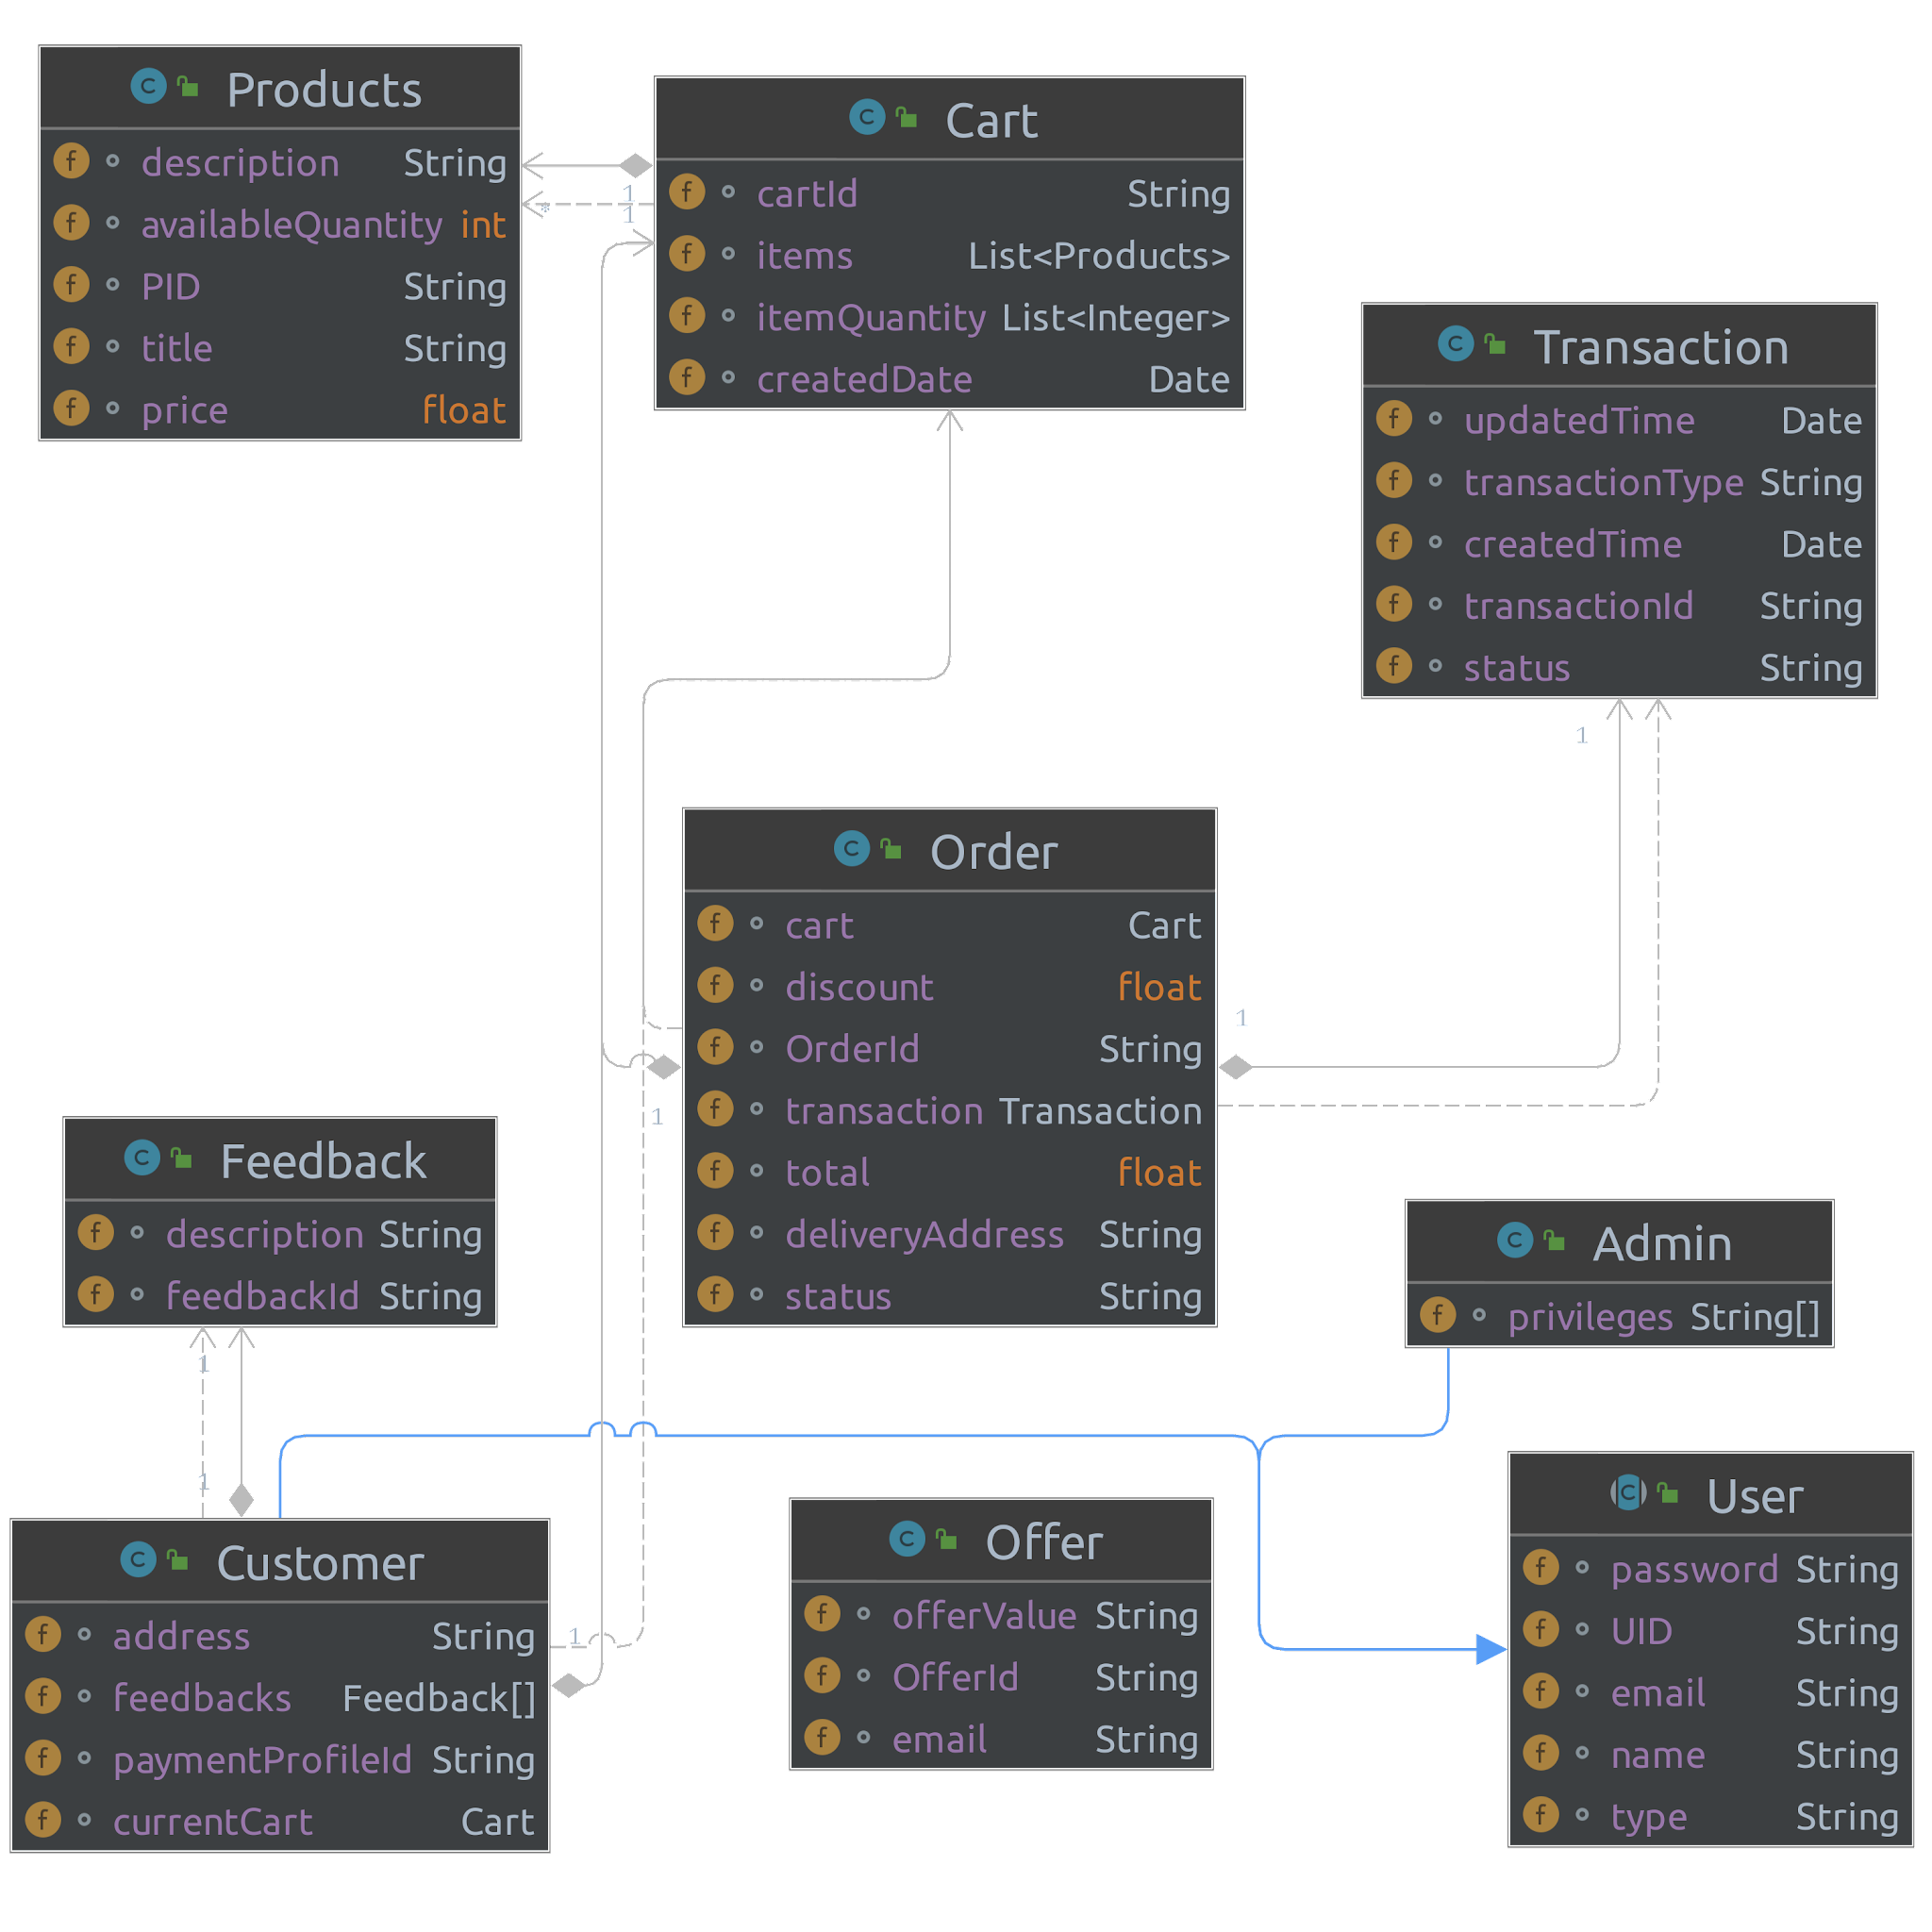

*Figure 12: Class Diagram*

### Entity Relationship Diagram

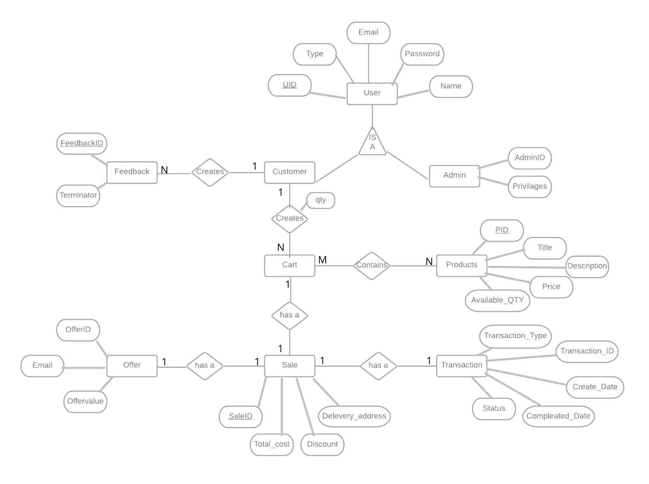

*Figure 13: Entity Relationship Diagram*



**Activity**

**Diagram**

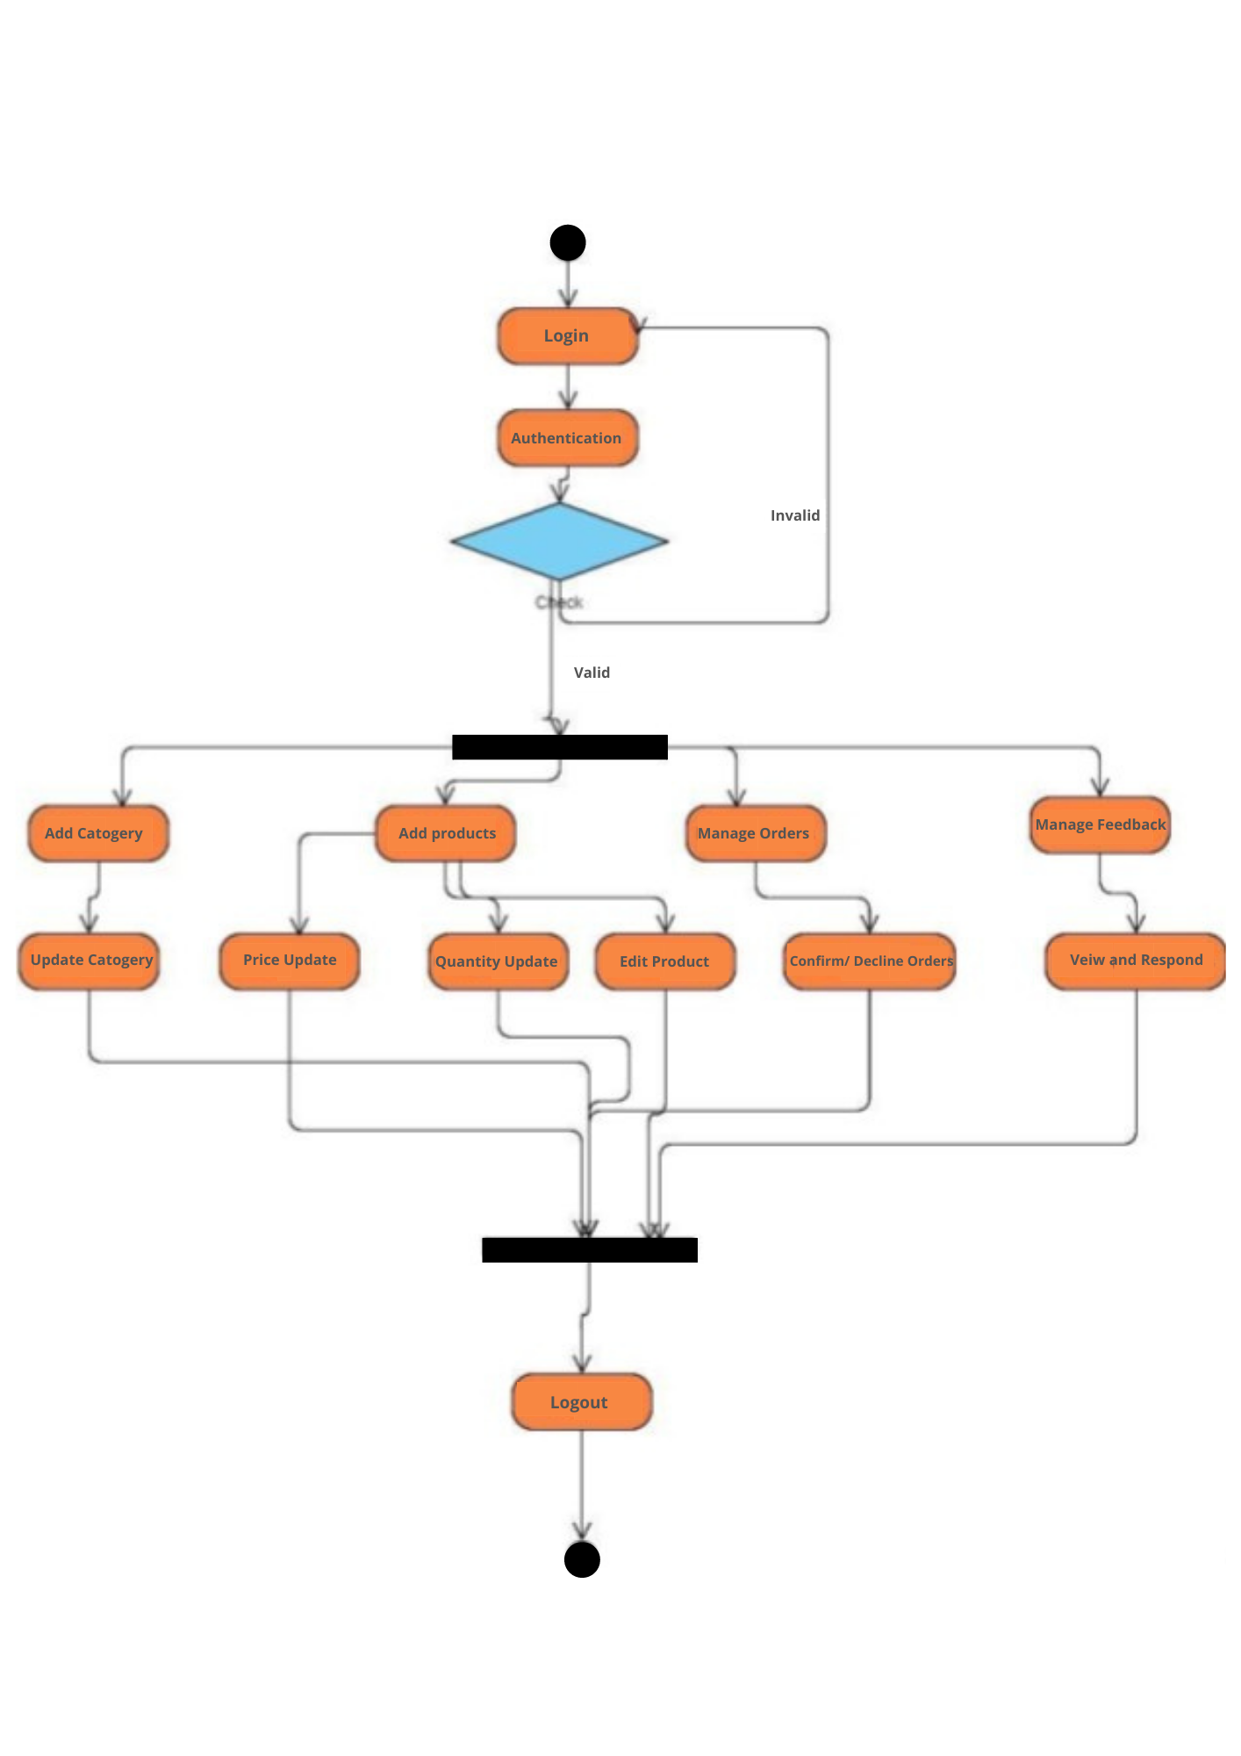

**SKANDA by Sarasi Samarasundara**

*Figure 14: Activity Diagram*

## 5 Other Nonfunctional Requirements

Non-functional requirements of the software requirement specification are discussed in this section under the subcategories of performance requirements, safety requirements, security requirements, and software quality aspects.

### 5.1 Performance Requirements

The proposed website is only highly efficient if performance criteria are stated. To evaluate performance requirements, the following criteria are used.

1. Response Time

Any user interaction with the proposed e-commerce website should be quick and should complete within 10 seconds. The proposed website should be interactive, and the system must respond quickly to each action in a shorter time. There should be no delays or interruptions in operations performed when connecting to the database. Also, actions such as linking, sorting, estimating, and publishing files required for storage will take less duration.

1. Workload

The proposed system must be capable of assisting all users in fulfilling their tasks without any hassle.

1. Scalability

The proposed system should be able to manage and maintain the increased workload as the number of users continues to expand. As new users join, the system response time should be maintained. In case of a hardware limitation, the system should be able to be migrated to a better server.

### 5.2 Safety Requirements

Since all of the application's data is stored on a single database server, generating frequent backups is necessary in case of system failure. The system will include automatic backups regularly. These backups will be kept in secondary storage and stored securely. In addition, when operations such as deleting, there will be a confirmation notification that appears to assure authenticity. It is possible to obtain a report on change history about actions performed on the existing items.

### 5.3 Security Requirements

Due to the system information being sensitive in nature, data protection throughout storage, transmission, and storage is necessary to assure data security. All the data exchanged between the webbrowser and the web server will be encrypted using the HTTPS technology to prevent man-in-the-middle attacks. Confidential user data, such as passwords, will be encrypted before being saved into the database. All user access and modifications will be recorded in the system for reference purposes. Safety is a system's capability to minimize the risk of malicious or unexpected actions beyond the system's intended usage and to prevent security breaches or losses.

The suggested system guarantees protection against potential attacks. Include solutions for forgotten passwords, account lockouts, idle session expiration, and avoiding storing plain text passwords, among other things. The vital principle is that a user's activity or data should not be changed in any manner between the time it leaves the user's computer and the time it is recorded in the database.

### 5.4 Software Quality Attributes

In this section, the software quality attributes of the SRS are discussed through developer productivity, elegance, usability, security, reliability, performance, scalability, testability, interoperability, transparency, and troubleshooting.

* **Usability** – The system should be created and built according to the specifications and restrictions determined throughout the review process. All interactions should be tested in various scenarios, including those that are unusual. Check to see if the system can consistently produce the desired results. The system should be simple to use and navigate without lagging. Even someone with minimal technical understanding should be able to access and navigate the system.

* **Reliability** – The system's reliability derives from the usability mentioned above. The system should always give accurate information. There shouldn’t be discrepancies between what’s shown to the user and what is actually recorded in the database.

* **Learnability** – With minimum computer literacy, any user should be able to utilise the system.

* **Maintainability** – It should be hassle-free to troubleshoot issues and modify or extend the website's functionalities. Admin should be able to rapidly and efficiently create, read, update and delete data.

## 6 Other Requirements

Apart from the things that will be changed throughout the project, current content must be added to the database ahead of time to ensure a smooth application launch. Because of this, transactions, customer relationship management, and inventory management will all work seamlessly after implementation.

## 7 Appendix A: Glossary

*Table 8: Definitions, Acronyms, and Abbreviations*

|  |  |
| --- | --- |
| **Term** | **Definition** |
| SRS | Software Requirement Specification |
| SDE | Software Development Environment |
| OS | Operating System |
| System | Digitalizing Shimano Inventory Management System |
| UI | User Interface |
| B2B | Business to business |
| Web-API | An application programming interface (API) for a web server or a web browser is known as a Web API. |
| PC | Personal Computer |
| ER Diagram | Entity Relationship Diagram |
| CPU | Central Processing Unit |
| App | Application |